**INTRODUCTION**

 In this laboratory, students will investigate and compare rates of cellular respiration. Students will investigate an original scientific question and will design an experiment to test their hypothesis. A variety of model organisms will be present for students to choose for their studies.

**OBJECTIVES**

After completing this laboratory, you should be able to:

* Explain the basic process of cellular respiration and how it is responsible for carrying out the energy conversions required by the organism to survive.
* Compare the rates of cellular respiration of different organisms OR investigate an environmental factor on rate of cellular respiration
* Calculate the rate of reaction of cellular respiration for different organisms and use this data to explain what is occurring at the cellular level.
* Design an inquiry experiment to test an original research question.

**BACKGROUND**

Cellular respiration is the process by which all organisms convert glucose, or other organic macromolecules into ATP, which can be used to perform cellular work. The overall process is divided into four major sets of reactions. The first is known as glycolysis and involves a series of metabolic steps that convert glucose into pyruvate, producing a bit of ATP and NADH (an electron carrier molecule). If enough oxygen is available, pyruvate is transported into the mitochondria (in eukaryotes) and attached to coenzyme A. This reaction produces more NADH. What is now acetyl CoA is picked up by the third process of cellular respiration known as the Citric acid, or Krebs cycle. This is a catabolic pathway, involving numerous enzymes that break off one carbon atom at a time from what was once glucose. As this cycle progresses carbon dioxide is released, a bit of ATP is produced, and high energy electrons are picked up by molecules of NADH and FADH2. This process is a cycle because oxaloacetate is regenerated in order to continue accepting molecules of acetyl CoA. At this point in cellular respiration, only about 4 net ATP have been generated. Most of the energy that was once in the original glucose molecule is in the high energy electrons that are being carried by NADH and FADH2. These electron shuttles drop off their cargo at the electron transport chain, where they are used to establish a concentration gradient of protons (H+) and manufacture about 28-30 additional ATP.

|  |
| --- |
| C6H12O6 + 6O2 🡪 6CO2 + 6H2O + ATP |

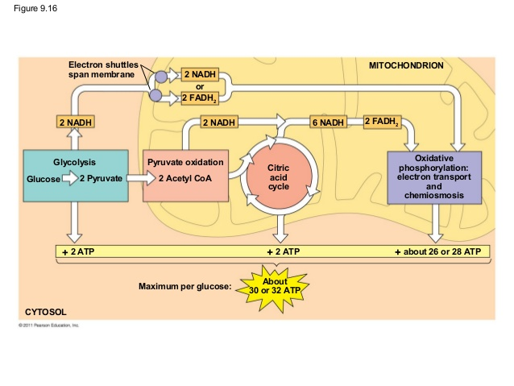

***IMPORTANT:***

* ***You and your group are responsible for obtaining, transporting, and caring for your organisms.***
* *Remember that you are working with live organisms! Treat them with care and respect.*
* *Although the materials in this lab are nonhazardous, follow normal safety precautions. Wash hands thoroughly with soap and water before leaving the laboratory.*

**Part I: Research Model Organism**

1. Go online and collect information about the organism you will be using for your cellular respiration investigation. You should focus on information such as:
   1. Describe the environment you would typically find this organism in.
   2. Are these organisms ectothermic or endothermic? How does this relate to cellular respiration?
   3. Where/how do these organisms obtain their energy source?
   4. Explain how the organism carries out respiration. Include a discussion of the organs/structures that enable the organism to carry out gas exchange.
   5. What life stage is this organism in? How might an organism’s life stage impact it’s requirements for cellular respiration?
   6. Are there any additional environmental factors that might impact the rate of cellular respiration in your organism?

**Part II: Planning & Implementing Your Experiment**

1. You will need to construct a chamber for your research specimens that is able to form an air-tight seal with one of the Lab Quest pro sensors. You will need to think about the materials/how you will construct this chamber and have it ready to go in class on lab day.
2. Identify the following before progressing to the rest of your procedural design:

* **Scientific Question**
* **Experimental Hypothesis (“If…then…because…”)**
* **Experimental group**
* **Control group**
* **Constants**
* **What data will you collect, how often, for how long?**
* **Sketch a table below that you will use to record your data**

*\*On a separate sheet of paper, or a class whiteboard, list the materials you will need, sketch what your choice chamber will look like, and plan out the rest of your formal procedure. If you use a whiteboard, take a picture of your final plan!*

**Part III: Analyzing Your Data**

* What kind of graph would be most appropriate to display your data? You may include more than one if appropriate. Explain your answer.
* Sketch the graph(s) below, making sure to label your x and y axis (including units) and a title.
* Summarize the most important trends that you notice in your data in the space below. Are there any calculations you should perform?

**Part IV: Discussion of Results**

Finally, you need to interpret the results and draw conclusions. Be sure to include the following information in your discussion:

1. Refer back to the experimental hypothesis.
2. Was there any support for the experimental hypothesis?
3. Rate of reaction
   * Be sure to compare the reaction rates that you have calculated for each organism/treatment group.
4. Propose a model for how rates of cellular respiration changed/are different in your model organism(s).
   * What generalizations can you make about the organisms under study based on the collected data?
   * Make sure you can explain your results in terms of
     + The biology of your model organisms.
     + The reactions of cellular respiration.
5. Identify and discuss potential sources of error.
   * Identify at least one potential source of error.
   * Explain how the source of error impacted your data.
   * Propose at least one improvement to the experimental design that would correct for the source of error.
   * Predict how this improvement might alter future data collection.